Title of the paper
AuthorA¹ – AuthorB² – AuthorC³

¹⁻²Workplace of AuthorA and AuthorB
¹email of AuthorA

²email of AuthorB

³Workplace of AuthorC
³email of AuthorC
Abstract: Short summary of the article, 500-1500 character.
Keywords: 5-10 typical terms; separated with semicolons
Introduction
We can list only one workplace per author, please select the one you need accordingly. Authors working/affiliated to the same places can list their workplace once. We ask you to list the email of all of the authors. Other data provided (e.g. job title, phone number, address, 2.workplace, etc.) will be deleted.
Please, don’t forget to fill the header (top of the page).
You can use this template. It contains the right settings (page settings, margin, etc.) and makes it easy to edit the article to the same format. Please leave the printing settings as the settings of this template. Fonts vary according to functions (headline, author, text etc.), please use them according to this template. Settings of the functions can be accessed in the styles.
The lenght of the article have to be between 6-12 pages.

Heading 1
Please refrain from overuse of subsections.

Heading 2
If possible, every level of heading should have been followed by some text, please refrain from stacking them.

Heading 3
Usage of more subheadings is not supported, please use paragraphs for articulation..
For lists please use the following pattern:
- list a
list b
list c
- list c/a
- list c/b
list d
last row of list (ends with punctuation).

Figures, equations
Insert pictures, images and figures in a separate paragraph. The caption can be automatically numbered and should be centred, according to the pattern shown in Figure 1.
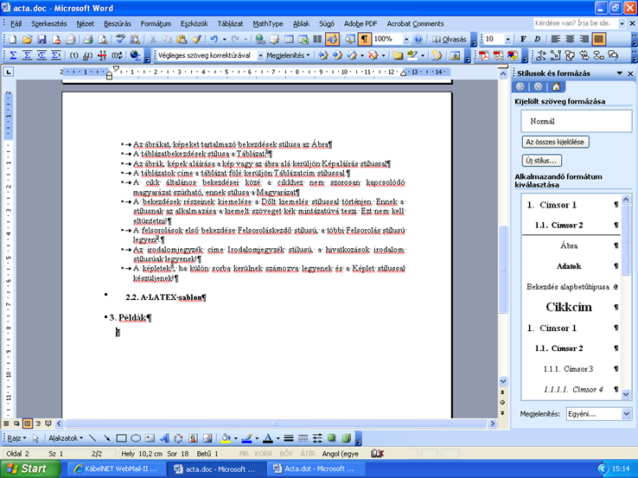
Figure 1. Figure template
Figure numbers are sequential irrespectively of their type.
Tables have own sequential numbers. The table should be centered, the caption needs to be above the table, as it can be seen on Table 1.
Table 1. Table-head style
 | x₁ | x₂ | x₃ | x₄
y₁ | 0 | 1 | 1 | 0
y₂ | 1 | 1 | 0 | 1
y₃ | 1 | 0 | 0 | 1
Equations should be made by built-in editor, not inserted as pictures and have their own sequential number as below.
Some examples:
(1)
(2)
(3)
Conclusions
The paper framed by the Introduction and Conclusions. These parts have no other title and are not numbered.
Please check the page settings , published styles, other formal criteria and page limits before closing.
Submit the article in the same (Word) format using the link provided on the website!

Acknowledgement: (please give it here, if it is relavant)
References
- Horváth, B. – Pfister, J.: Galileo in urban public transport, Acta Technica Jaurinensis 2012 Vol.5. No.3. 263-270
- Horváth, B. – Horváth, G.: Methodolgy of public transport planning, European Society of Transport Institutes (ESTI) Young researcher’s conference, Paris 1998. october 2-3.
- de Palma, A. – Lindsey, R. – Quinet, E. – Vickerman, R. (eds.): A handbook of transport economics, Edward Elgar Publishing Limited, Cheltenham, 2011.
- http://cots.sze.hu/ (2017.11.30.)

References should be listed by order of occurence in:
[1] reference for article
[2] reference for conference presentation
[3] reference for book
[4] reference for webpage, (with the date of the visitation in round bracket)
In the text use [ ] to give the number of the reference. Please don’t use footnote.

